Updated 1/7/24

Blue - MS/HS Snow & Emergency Route

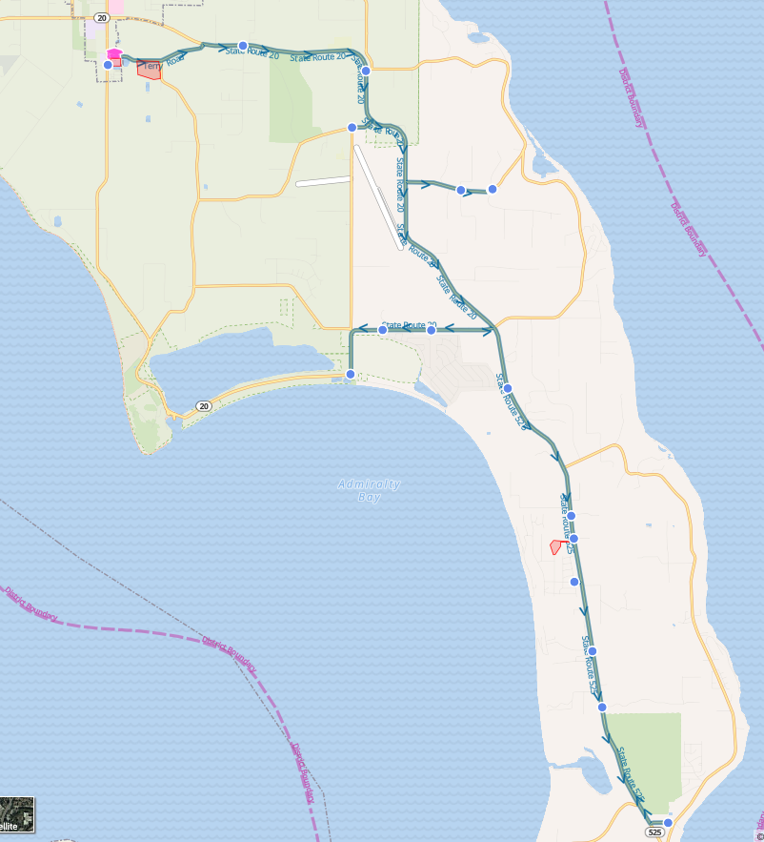

Blue - MS/HS Snow & Emergency Route

Reg Start 2- Hr. Delay
6:49 AM | 8:49 AM |  | Hwy 20 & Jacobs Rd
6:51 AM | 8:51 AM |  | Hwy 20 & Safari St
6:58 AM | 8:58 AM |  | Hwy 20 & Keystone Ave
7:00 AM | 9:00 AM |  | Hwy 20 & Koenig Ln
7:01 AM | 9:01 AM |  | 15736 Hwy 20
7:02 AM | 9:02 AM |  | SR 525 Admirals Cove Transit Stop
7:14 AM | 9:14 AM |  | Ledgewood Beach Rd & Virginia Ave
7:17 AM | 9:17 AM |  | SR 525 Teronda Transit Stop
7:20 AM | 9:20 AM |  | Wonn Rd (Greenbank Farm Drive)
7:22 AM | 9:22 AM |  | SR 525 & Ellwood Dr
7:26 AM | 9:26 AM |  | SR 525 & Carnica Way
7:26 AM | 9:26 AM |  | SR 525 & Rosie Ln
7:33 AM | 9:33 AM |  | Welcher Rd & Stillmeadow Rd
7:34 AM | 9:34 AM |  | Welcher Rd & Hobart Rd
7:38 AM | 9:38 AM |  | Patmore Rd & Keystone Hill Rd

Blue - Elementary Snow & Emergency Route

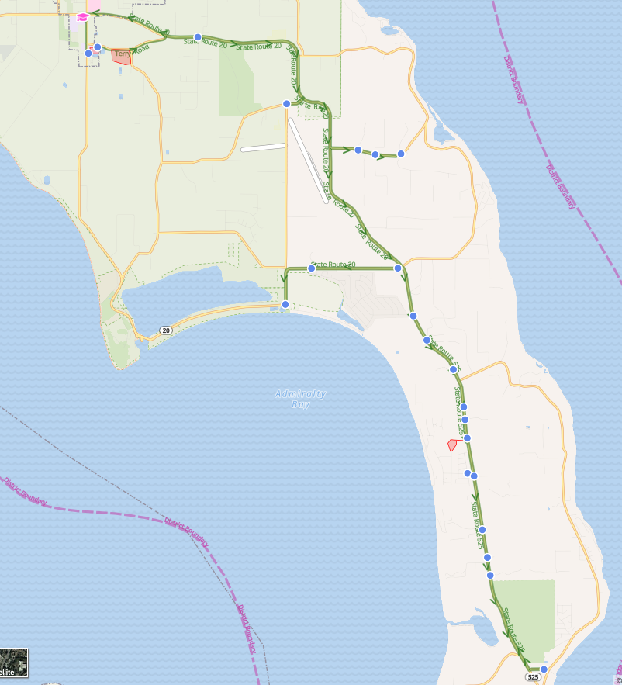

Blue - Elementary Snow & Emergency Route

Reg Start 2- Hr. Delay
7:52 AM | 9:52 AM | Hwy 20 & Jacobs Rd
8:01 AM | 10:01 AM | Hwy 20 & Keystone Ave
8:02 AM | 10:02 AM | Hwy 20 & Koenig Ln
8:04 AM | 10:04 AM | Hwy 20 & Hwy 525 (Park and Ride)
8:05 AM | 10:05 AM | SR 525 Admirals Cove Transit Stop
8:15 AM | 10:15 AM | 29069 SR 525
8:17 AM | 10:17 AM | Ledgewood Beach Rd & Virginia Ave
8:23 AM | 10:23 AM | SR 525 Teronda Transit Stop
8:27 AM | 10:27 AM | Wonn Rd (Greenbank Farm Drive)
8:29 AM | 10:29 AM | SR 525 & Ellwood Dr
8:29 AM | 10:29 AM | 27024 SR 525
8:31 AM | 10:31 AM | SR 525 & Cox Dr
8:31 AM | 10:31 AM | SR 525 & Carnica Way
8:32 AM | 10:32 AM | SR 525 & Rosie Ln
8:32 AM | 10:32 AM | 28730 SR 525
8:34 AM | 10:34 AM | SR 525 & Aloha Pl
8:39 AM | 10:39 AM | Welcher Rd & Wondering Ln
8:39 AM | 10:39 AM | Welcher Rd & Stillmeadow Rd
8:40 AM | 10:40 AM | Welcher Rd & Hobart Rd
8:44 AM | 10:44 AM | Patmore Rd & Keystone Hill Rd

